SURVEILLANCE BOT

OBJECTIVE: We will make a bot which runs using ps2 controller with avr atmega 128 microcontroller.This bot also capture videos using webcam interfaced with raspberry pi 3b+ and video will be live streamed on the laptop.

There are mainly three modules in this system.

1)interfacing ps2 controller with atmega 128 using spi protocol.

2)Differential driving.

3)live streaming videos using raspberry pi 3b+.

SPI PROTOCOL – SERIAL PERIPHERAL INTERFACE

SPI(Serial peripheral interface) protocol is used to communicate between microcontroller and any other sensor or controller. For spi there are mainly four pins on the microcontroller-MOSI(master out slave in),MISO(master in slave out),SCK(clock),SS(slave select). In spi there will be one master and there can be multiple slaves depending upon the system, normally the ss pin is kept HIGH anad to select that slave to communicate we LOW the ss pin associate with it.master initialise the communication between them and communication between them is done at the clock set by master. To see the different registers in spi and their functionality and how to use it see the data sheet of atmega 128.

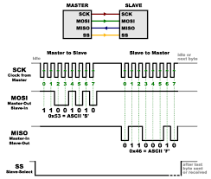

PS2 CONTROLLER

In ps2 controller there are mainly nine pins,the important ones in this project are-data pin(connected to MISO of microcontroller),command pin(connected to MOSI of microcontroller),ground,vcc(3,3V),att[attention](connected to ss pin of MCU) and clk[clock](connected to sck of MCU).Here sck and data pins are needed to be pulled high using 10 Kohm pullup resistor.To configure ps2 controller and to take inputs from ps2 controller we have to give it specific commands from microcontroller.

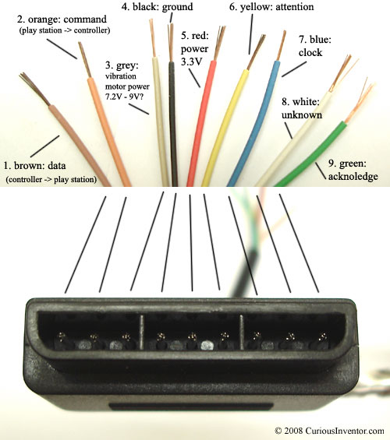

INTERFACING PS2 CONTROLLER WITH MICROCONTROLLER USING SPI PROTOCOL.

WHAT I DID IN THIS PROJECT?

I learned about spi protocol and ps2 controller completely.I interfaced ps2 controller with atmega 128. onput is coming properly to microcontroller,but getting trouble in converting bytes of 0s and 1s as an output to a single value refrence using which we can run bot with different if-else condition.

Also I have circular mapped the square coordinate system of the joysticks to circular one ,as in square coordinate system the output value can go beyond the diagonal value but in circular system maximum value can’t change.

I also helped in designing circuit and solder it, and also learn about basics of raspberry pi,how to install rasbian os on it and also researched on interfacing webcam with raspberry pi.